**Q1. Simulate a small network with switches and multiple devices.**

Simulation tool : Cisco Packet Tracer

Created a Small network with a switch and 3 PCs and assigned Static IP addresses for all PCs and Ping one PC from another

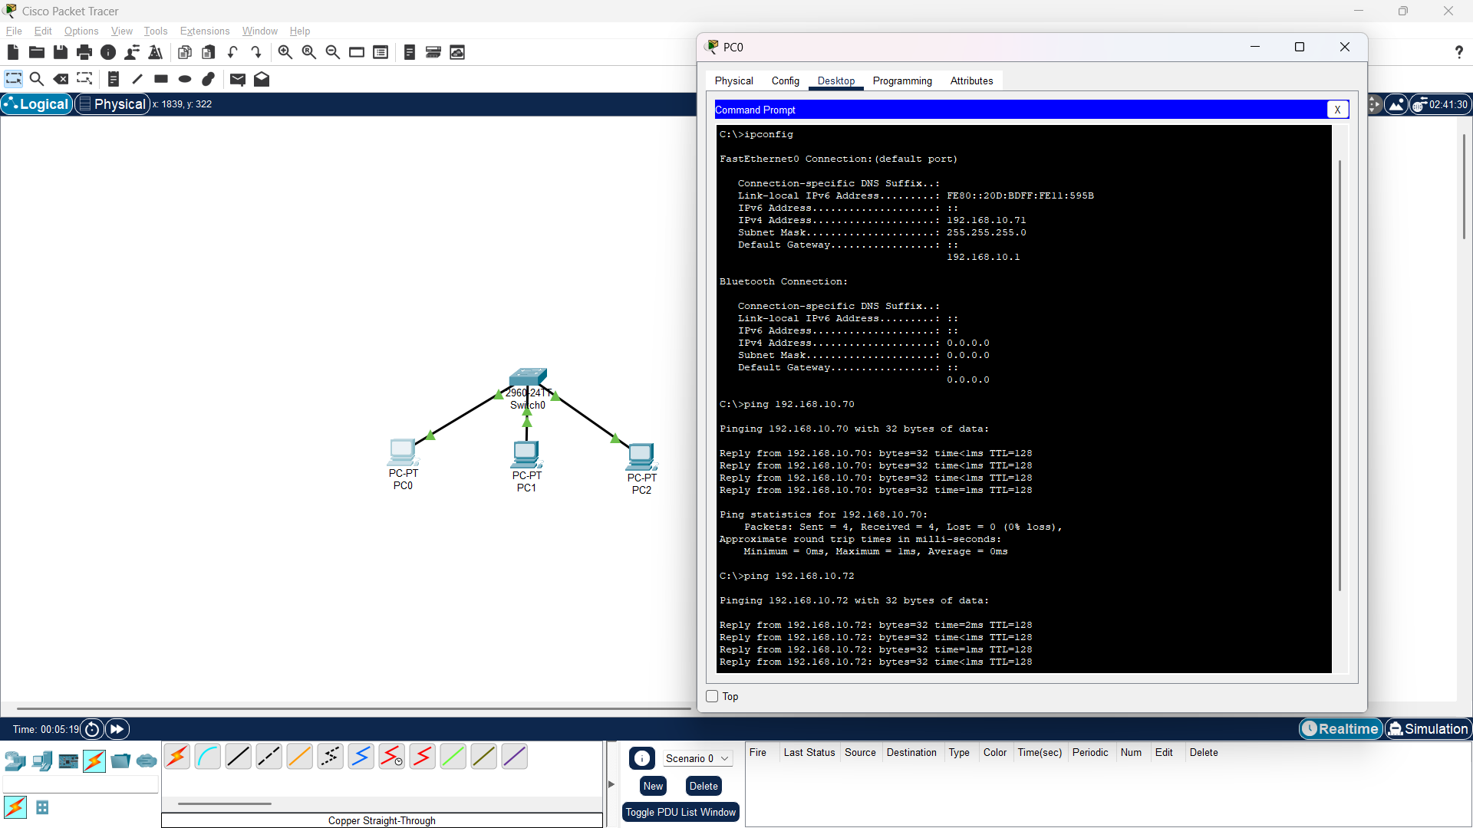

Use ping to generate traffic and observe the MAC address table of the switch.

Observed the ARP and MAC addresses using Simulation And event list   
And took MAC addresses from the Switch using CLI

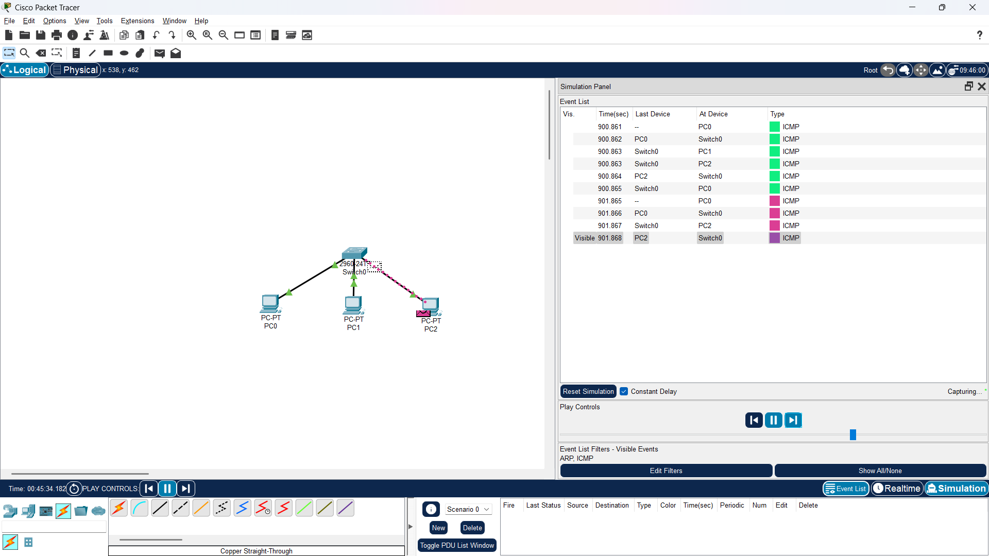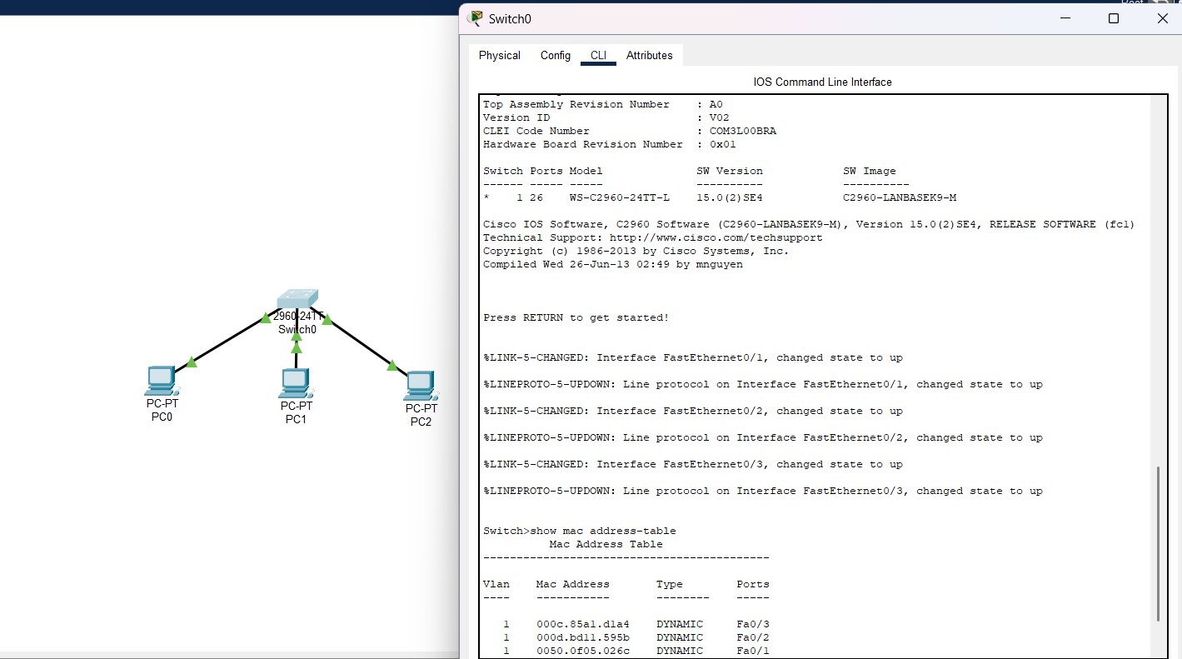

**Q2. Capture and analyze Ethernet frames using Wireshark. Inspect the structure of the frame, including destination and source MAC addresses, Ethertype, payload, and FCS. Use GNS3 or Packet tracer to simulate network traffic.**

Before ARP ,

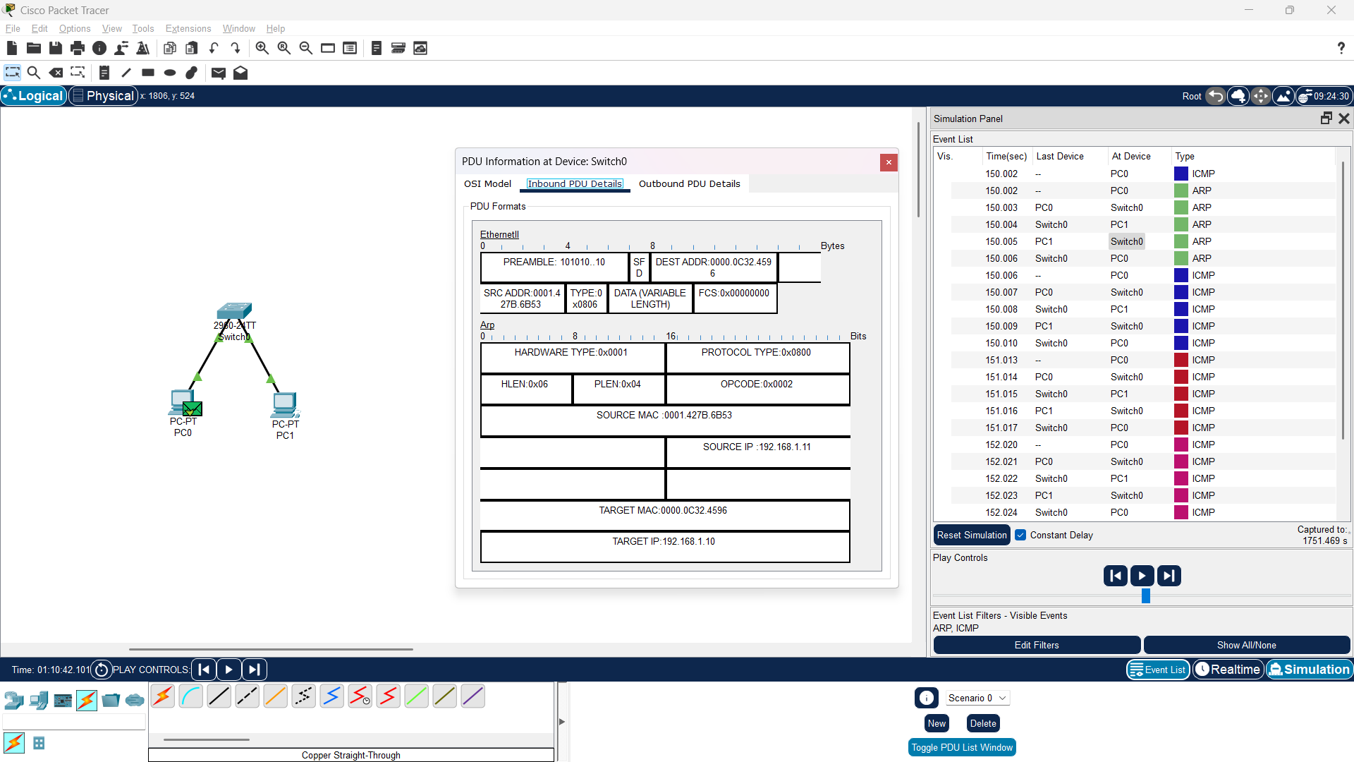

After ARP ,

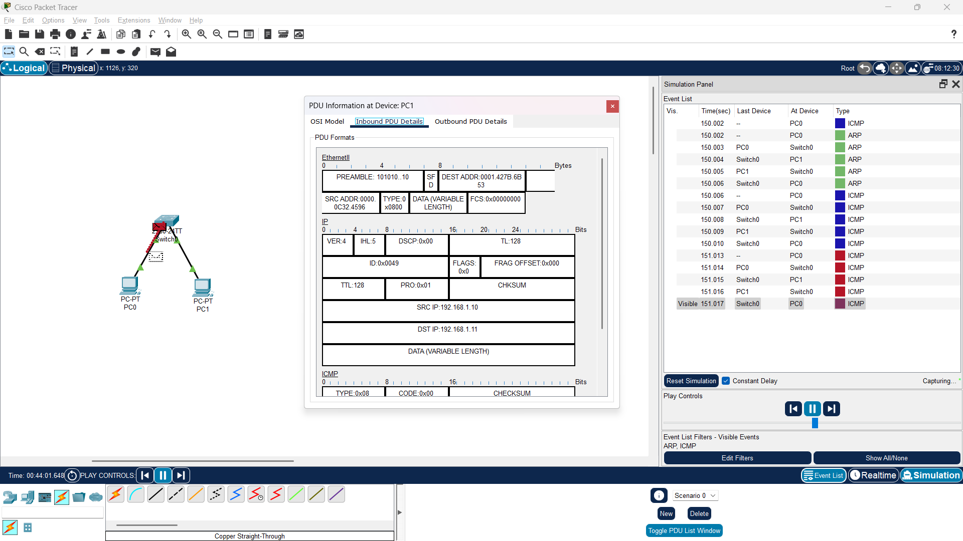

**Q3. Configure static IP addresses, modify MAC addresses, and verify network connectivity using ping and ifconfig commands.**

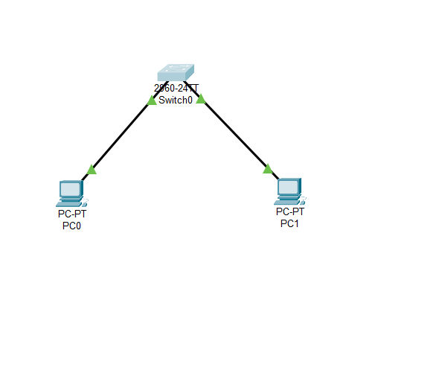



### Use Port Security to Assign a Specific MAC Address

Instead of changing the MAC address of the switch port directly, we can assign a specific MAC address to a port using port security.

### Steps:

1. Open the Switch CLI.

Enter configuration mode:  
 shell  
CopyEdit  
enable

configure terminal

1. Select the interface connected to PC-0 (e.g., FastEthernet 0/1):  
    shell  
   CopyEdit  
   interface FastEthernet 0/1
2. Enable port security and assign a MAC address:  
    shell  
   CopyEdit  
   switchport mode access

switchport port-security

switchport port-security mac-address 0060.2fd1.d9c9

000A.BCDE.1234

1. Exit and repeat for PC-1’s port (FastEthernet 0/2):  
    shell  
   CopyEdit  
   interface FastEthernet 0/2

switchport mode access

switchport port-security

switchport port-security mac-address 000A.BCDE.5678

Exit

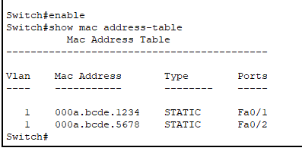

**Q4. Create a simple LAN setup with two Linux machines connected via a switch.**

**Q5.Ping from one machine to the other. If it fails, use ifconfig to ensure the IP addresses are configured correctly.**

**Q6.Use traceroute to identify where the packets are being dropped if the ping fails.**

Simulation using Cisco packet tracer  
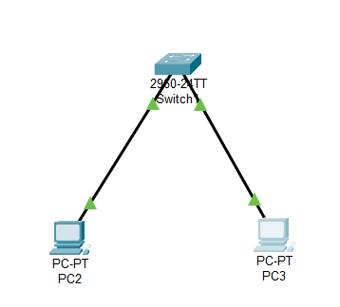  
  
Ip configuration for PC2 and PC3

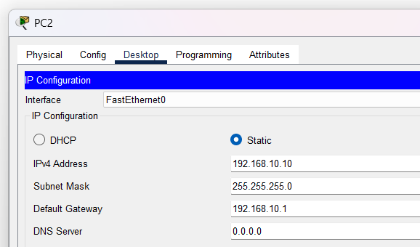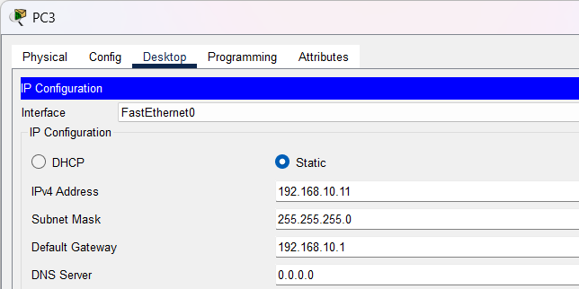

Ping , Traceroute and ipconfig from PC3  
  
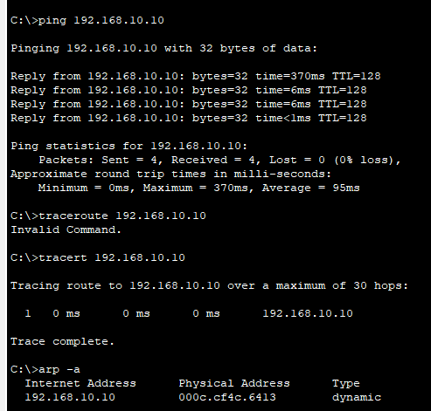

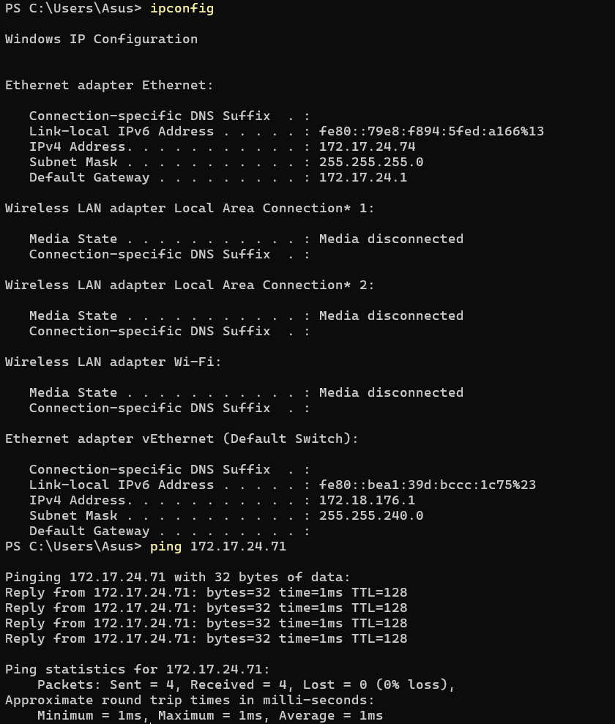

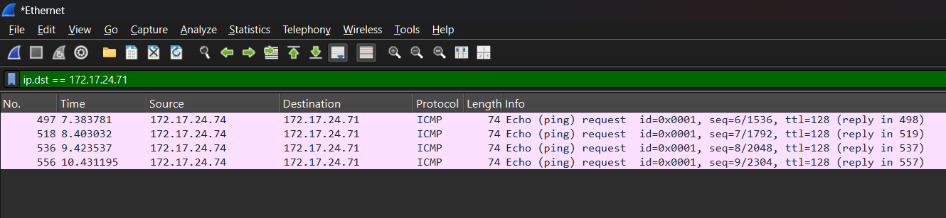

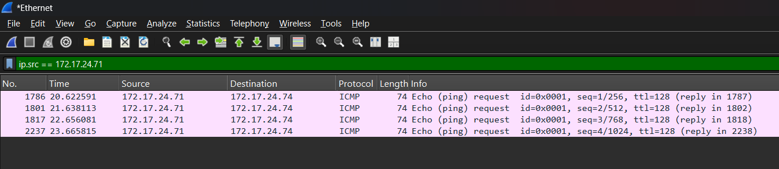

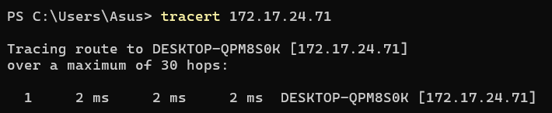

**Q7.Research the Linux kernel's handling of Ethernet devices and network interfaces. Write a short report on how the Linux kernel supports Ethernet communication (referencing kernel.org documentation).**

* The Linux kernel manages Ethernet communication through the **netdev subsystem**.
* Network interfaces are represented as **struct net_device** and handled via kernel drivers.
* Uses **NAPI (New API)** for efficient packet handling, reducing CPU overhead.
* The **skb (socket buffer)** structure is used for packet transmission and reception.
* Ethernet drivers (e.g., e1000, r8169) provide hardware-specific support.
* Detailed documentation available at kernel.org.

**Q8: Configuring a Basic LAN Interface using the ip Command**

Check available network interfaces

ip link show

This lists all network interfaces on the system, including their statuses.

Assign an IP address to an interface

sudo ip addr add 192.168.1.100/24 dev eth0

This assigns the IP address 192.168.1.100 with a subnet mask of /24 (255.255.255.0) to the eth0 interface.

Enable the interface

sudo ip link set eth0 up

This brings the eth0 interface online.

Set a default gateway

sudo ip route add default via 192.168.1.1

This adds a default route through the gateway 192.168.1.1, allowing traffic to leave the local network.

**Q9: Viewing the MAC Address Table on a Linux-Based Network Switch**

Check the MAC address table using the bridge command

bridge fdb show

This displays the Forwarding Database (FDB), listing MAC addresses learned by the switch along with their associated interfaces.

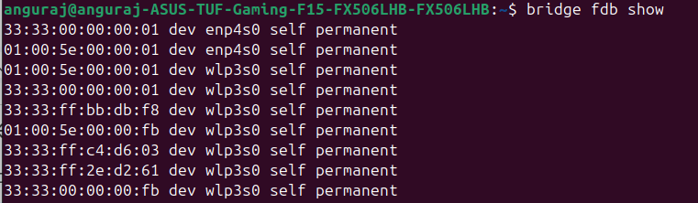

View interface statistics using the ip link command

ip -s link show eth0

This shows statistics for eth0, including packet counts and errors, which help in diagnosing network issues.

